**Root production in a subtropical pasture is mediated by cultivar and defoliation severity**

CHRIS H. WILSON1, JOAO M. VENDRAMINI2, LYNN E. SOLLENBERGER1 AND S. LUKE FLORY1

1*Agronomy Department, University of Florida, Gainesville, FL, USA.* <https://agronomy.ifas.ufl.edu/>

2*Range Cattle Research and Education Center, University of Florida, Ona, FL, USA*. <https://rcrec-ona.ifas.ufl.edu/>

Correspondence: Chris H. Wilson, 1676 McCarty Drive, Gainesville, FL 32611, USA. Email: [chwilson@ufl.edu](mailto:chwilson@ufl.edu)

Running Title: Root production mediated by cultivar and defoliation

**Abstract**

Grasslands occupy significant land area and account for a large proportion of the global soil carbon stocks, yet the direct effects of grazing and genotypic composition on relationships between shoot and root production are poorly resolved. This lack of understanding hinders the development of models for predicting root production in managed grasslands, a critical variable for determining soil carbon stocks. We quantified the effects of season-long defoliation treatments on both shoot and root production across 4 cultivars of a widely-planted pasture grass species (*Paspalum notatum* Fluegge) in a common garden setting in South Florida, USA. We found that infrequently applied (4 week) severe defoliation (to 5 cm) substantially enhanced shoot production for all cultivars, while severe defoliation reduced root production across cultivars, regardless of frequency. However, there was no significant relationship between shoot and root production. Our results showed that above-ground and below-ground productivity are only weakly coupled, suggesting caution against use of simple above-ground proxies to predict variations in root production in grasslands. More broadly, our results demonstrated that improved modeling and management of grasslands for below-ground ecosystem services, including soil carbon sequestration/stocks, must account for intraspecific genetic variations and responses to defoliation management.

Keywords: Grazing management, genotypic variability, subtropical grassland, belowground production

**Introduction**

**Abstract Guidance – remove this box before submitting!**

* No more than approx. 500 words (or 3,000 characters).
* Self-contained and concisely describe the reason for the work, methodology, results, and conclusions. Uncommon abbreviations should be spelled out at first use. Do not include footnotes or rferences.
* Headings in structured abstracts should be bold and followed by a period. Each heading should begin a new paragraph. For example:

**Background.** The background section text goes here. Next line for new section.

**Methods.** Methods section here, then new line.

**Results.** Results section here, then new line.

**Discussion.** Discussion section here.

Grassland ecosystems occupy more than a fifth of earth’s land area and account for a large proportion of the global soil organic carbon (SOC) stocks (Scurlock and Hall 1998; Lal 2010). However, there is considerable uncertainty in predictions of net ecosystem exchange, and hence carbon sequestration services from grasslands (Gilmanov et al. 2007; Cahill et al. 2009). One significant source of uncertainty is that, while large herbivore grazing is known to mediate patterns of plant species composition, diversity and above-ground primary productivity (McNaughton 1985; Knapp et al. 1999; Fuhlendorf and Engle 2001), the effects of grazing on below-ground processes and soil carbon are less clear (McNaughton et al. 1998; Hamilton and Frank 2001; McSherry and Ritchie 2013; Balogianni et al. 2014) In particular, there are limited field studies where the impact of grazing on root production in grassland systems has been directly measured (e.g. via root ingrowth cores or minirhizotron technology; see Ziter and MacDougall 2012; Balogianni et al. 2014; Cooley et al. 2019). Since below-ground production may be the largest component of total net primary productivity (NPP) for many grasslands (Gill et al. 2002; Hui and Jackson 2006), determining how grazing affects root production will help to predict when grassland ecosystems will behave as carbon sinks, and whether grazing is likely to promote or inhibit carbon sequestration services.

Root carbon inputs may constitute a disproportionate amount of the total SOC stock compared with shoot carbon (Rasse et al. 2005; Poirier et al. 2018; Sokol et al. 2019), and are especially critical in grassland ecosystems where above-ground tissue is susceptible to frequent removal by fire and grazing (Johnson and Matchett 2001). Current understanding of how grazing affects root production is ambiguous. For example, one temperate mesocosm study showed that intense defoliation inhibited root production and accelerated the loss of SOC (Klumpp et al. 2009), whereas some field studies have documented greater below-ground allocation and root production under grazing in the Tibetan plateau (Hafner et al. 2012) and in subtropical pasture (Wilson et al. 2018). Augustine et al. (2011) found that defoliation reduced below-ground carbon allocation in one grazing-adapted North American grass species (*Pascopyrum smithii,* western wheatgrass) but not in another (*Bouteloa gracilis,* blue grama), highlighting interspecific variations in response to a given defoliation regime*.* In general, laboratory and mesocosm studies have found that frequent grazing/defoliation leads to declines in standing root biomass over the long term (Bardgett et al. 1998), whereas a global synthesis of data comparing grazed and ungrazed grasslands found a mix of positive and negative effects on standing root biomass (Milchunas and Lauenroth 1993). Overall, this discordance suggests that variations in plant composition, underlying environmental factors, grazing intensity or some combination of these factors significantly mediates the effects of grazing on root production.

Grazing effects on below-ground production may vary based on not only plant species but also the genotypic composition of a grazed stand, given the increasing evidence of the importance of intraspecific variation in driving ecosystem structure and function (Madritch and Hunter 2002; Whitham et al. 2006). In general, some literature suggests that reduced allocation of photosynthates to roots (and increased allocation to shoots) following grazing may represent an evolutionarily adaptive trait for grazing tolerance (Briske and Richards 1995). For instance, Carman (1985) noted that short-leaved genotypes of *Schizachyrium scoparium,* selected from a long-term grazed site, exhibited lower rates of root elongation post-grazing than longer-leaved genotypes from a site where grazing was excluded for a long period. Planted pasture grasses have been shown also to exhibit genotypic variability in shoot and root production in response to grazing (e.g. Dawson et al. 2000). For example, Interrante et al. (2009) observed significantly less plant cover in recently-selected, upright-growing *Paspalum notatum* (bahiagrass) cultivars in response to severe, frequent defoliation, but cover was not reduced with the same defoliation treatments on widely-naturalized cultivars, suggesting significant intraspecific variability in grazing tolerance and below-ground biomass allocation.

Although root production is a critical component in predicting the carbon cycle in grassland ecosystems, it is difficult to monitor or predict over large spatial scales. Thus, regional-scale grassland models have been developed that predict total NPP and/or greenhouse gas exchange on the basis of above-ground canopy characteristics estimated from remote sensing (Houborg and Soegaard 2004; Li et al. 2012; Gu et al. 2013). Similarly, some previous work has sought to predict below-ground net primary productivity (BNPP) on the basis of readily obtained above-ground measurements in both grasslands (Gill et al. 2002) and forests (Chen et al. 2004). Recently, concerted efforts have been made to link fine root traits with other plant traits, across species and environments, by compiling and analyzing global-scale large datasets (Iversen et al. 2017). The goal is to have reliable above-ground proxies for predicting critical below-ground root processes (Malhotra et al. 2018). However, given the evidence for potentially significant genotypic and defoliation effects on below-ground carbon allocation, it is unclear whether above-ground proxies can ever reliably approximate root production. Given the central importance of root system carbon inputs to maintaining SOC, especially in grasslands, we need more data from experimental systems where genotypic composition and grazing management have been manipulated, and the relationships between above- and below-ground biomass allocation have been quantified.

In this study, we tested the independent and combined effects of defoliation intensity and frequency, and cultivar on root production of a widely-utilized pasture grass species of the southeastern United States, *Paspalum notatum* Flüegge (bahiagrass)*.* Bahiagrass cultivars can be broadly delineated on the basis of growth habit, as historically older, widely-naturalized cultivars tend to be prostrate, whereas modern cultivars tend to be upright, reflecting selection for improved forage growth characteristics (Vendramini et al. 2013). Previous work, and considerable producer experience, suggest that bahiagrass has a remarkable resilience to intense grazing, wherein forage growth and quality are maximized with severe defoliation (close to ground level) so long as regrowth intervals are adequate (Beaty et al. 1968; Stanley et al. 1977). However, impacts of defoliation severity on root production across cultivars, and their associated growth habits, have not been studied directly, reflecting a general lack of information on below-ground growth responses in subtropical pasture during the warm season (Cooley et al. 2019). To redress this gap in knowledge, we conducted an experiment in a common garden setting under realistic conditions of limited soil fertility in an endeavor to: isolate the effects on below-ground production of defoliation intensity and frequency plus cultivar; and evaluate the relationships between above-ground and below-ground growth.

Consistent with the literature on compensatory growth responses by natural and planted pastures (Stanley et al. 1977; McNaughton 1983; Zhao et al. 2008), and also with the literature on genotypic variability (e.g. Dawson et al. 2000), we hypothesized that:

1. Severe defoliation, applied infrequently, would stimulate increases in above-ground primary productivity (via compensatory response mechanisms), but would have neutral effects on root productivity across all cultivars;
2. Severe defoliation, applied frequently, would significantly suppress root production across all cultivars as a consequence of plant requirements to prioritize photosynthate allocation to regrowing shoots. Shoot production would either remain flat or decrease somewhat, as the higher level of stress over-rides compensatory growth mechanisms;
3. Widely-naturalized, prostrate cultivars would show proportionally greater reductions in root production under severe defoliation thanthe more upright cultivars, reflecting a beneficial adaptation for increased allocation to shoots following severe defoliation events; and
4. Despite alterations to below-ground biomass, allocation on the basis of cultivar and defoliation treatment, shoot production and root production would positively correlate at the plot level, reflecting variations in underlying soil factors determining total productivity.

**Materials and Methods**

To evaluate the independent and potential interactive effects of defoliation intensity and plantcultivar on root production, we established thirty-two 3 m × 7 m experimental plots at the University of Florida Range Cattle Research and Education Center, Ona, FL (27°26’ N, 82°55’W) in 2009. The soils were uniform and classified as Pomona fine sand (sandy, siliceous, hyperthermic Ultic Alaquod). First, we seeded plots with 1 of 4 bahiagrasscultivars (Argentine, Pensacola, Tifton-9 and UF-Riata). Bahiagrass is a perennial C4 pasture grass with improved germplasm that was introduced to Florida in the 1920s from South America and constitutes the primary forage for the Florida cow-calf industry (Silveira et al. 2011). ‘Argentine’ and ‘Pensacola’ are widely-distributed, naturalized cultivars in the state of Florida with a prostrate growth habit, whereas ‘Tifton-9’ and ‘UF-Riata’ are recently-released cultivars selected for improved agronomic characteristics, including more upright growth habit and less sensitivity to photoperiod (Interrante et al. 2009; Vendramini et al. 2013). Plots were fully established by the onset of the 2010 summer growing season with complete, uniform plant cover. More details, including soil fertility characteristics can be found in Vendramini et al. (2013). Weather data at the site for this period were accessed from the Florida Automated Weather Network (FAWN, <http://fawn.ifas.ufl.edu/data/>), including temperature, precipitation and evapotranspiration, and all fell within normal ranges (Table S1).

We initiated defoliation treatments on 13 June 2013 and concluded field sampling 16 weeks later on 5 October 2013. Although we did not measure soil moisture, all soils were visibly waterlogged from July until the end of the experiment, as is typical in Florida Spodosol soils (Silveira et al. 2011). We therefore assumed that plant growth was not limited by reduced water availability during the sampling period, or at the very least that water availability was essentially constant across plots. Each plot (n = 32) was randomly assigned to either a frequent (2 wk) or an infrequent (4 wk) defoliation treatment to simulate grazing stress and was halved to received 2 defoliation intensities (severe at 5 cm residual height, and mild at 15 cm residual height) resulting in n = 64 experimental units (Figure S1). Residual heights were chosen based on personal observation (C.H. Wilson, L.E. Sollenberger and J.M. Vendramini) to represent the extremes of pasture defoliation under grazing by beef cattle in Florida. Thus, our design was effectively split-plot with 2 main-plot treatments (cultivar and defoliation frequency), while our subplot factor was defoliation intensity. Overall, each cultivar × defoliation severity × defoliation frequency treatment was replicated 4 times.

We harvested forage from a 0.92 m2 quadrat within each subplot during each defoliation treatment using a rotary mower (Sensation Mow-Blo Model 11F4-0) at the target cutting heights. To quantify above-ground production, harvested material was oven-dried at 60 **°**C to constant mass and weighed on an analytical scale. At the final harvest, all subplots were harvested at 5 cm. Total above-ground production was determined by summing values for each subplot across all dates, including the final harvest.

To quantify root primary production in response to the defoliation treatments, we installed 2 mm mesh root in-growth cores (Makkonen and Helmisaari 1999) on 7 June 2013, prior to imposing the defoliation treatments. Cores were 7.5 cm diameter × 25 cm deep and constructed of fiberglass mesh. They were installed by first excavating soil with a soil auger to target dimensions, placing the mesh cores into the holes produced so that the upper edge of the core was just below the soil surface, and then re-filling the cores with sieved, root-free soil from the same plot. We retrieved the cores at the end of the growing season on 5 October 2013, 16 weeks after installation. The final volume of soil contained in each core was quantified prior to washing the roots free of soil on a 250 μM sieve. Roots were then oven-dried at 60 **°**C to constant mass and weighed. To correct for variation in core volume, root biomass was multiplied by a correction factor determined as the inverse of the ratio of each core volume to a reference core (a cylinder of 7.5 cm diameter and 25 cm depth). Finally, we visually verified that almost all root biomass was contained within the depth we evaluated (i.e. 25 cm depth) by digging several test pits around our study area. We noted from personal observation that wet pastures tended to result in shallower root distribution, consistent with early literature (Doss et al. 1960). Therefore, we multiplied root biomass by a constant to convert our measurements to g/m2, putting them on an easily interpretable scale.

*Statistical analysis*

Response variables for analyses were shoot and root production, and a measure of allocation of photosyhthate to root biomass defined as:

To analyze among-cultivar variability in response to our treatments, we parameterized a varying-intercept/varying-slope Bayesian hierarchical model that we applied to both response variables. In this model, we estimated intercept and slope (i.e. treatment effects) coefficients for each cultivar, where each batch of coefficients was modeled as a draw from a normal distribution with an estimated variance component (Gelman and Hill 2007). We included binary predictor variables using a -0.5/0.5 “effect coding” for our experimentally imposed treatments: lenient (15 cm) and infrequent (4 wk) defoliations were assigned -0.5 values, while frequent (2 wk) and severe (5 cm) defoliations were assigned 0.5 values. Under this coding, the model intercept represents the grand mean, and the coefficients for defoliation severity and frequency represent the main effects of severe and/or frequent defoliation across both levels of the other treatment (see e.g. Schabenberger et al. 2000). We also included a term for the interaction of severe and frequent defoliation treatments and a random effect of plot to allow for correlation in observations from the same plot. Our varying-intercept/varying-slope model therefore included 4 separate estimates of grand means (1 for each cultivar), each of which represented an estimate of performance for that cultivar across all defoliation treatment conditions, and 4 treatment effect estimates (1 for each cultivar) for frequent defoliation, severe defoliation and their interaction. Since these coefficients were drawn from distributions with estimated variance components, the separate estimates were partially pooled towards their common mean, which also was estimated from the data, a property that built in an automatic correction for multiple comparisons among cultivars and obviated the need for arbitrary post-hoc adjustments such as the Bonferonni correction (Gelman et al. 2012). Finally, because growth data are naturally constrained to be positive only and because we observed a pattern of variance increasing with the mean, we used a gamma distribution to model our data, which naturally accounts for this nearly universal pattern in biomass data. We used the standard log-link in our parameterization of the gamma regression model, and thus our model coefficients represent multiplicative effects, and are reported on the log-link scale (Gelman and Hill 2007). Values greater than zero indicate positive effects on the response variable, whereas values less than zero indicate negative effects. As in all cases where the log-link is used, exponentiation of these regression coefficients returns the multiplicative effect, which can be naturally interpreted as a % effect.

We display treatment effects graphically by first plotting estimated fixed effect coefficients (i.e. frequency, severity and frequency × severity) centered on the median, and include both 50% (thick) and 95% (thin line) uncertainty (credible) intervals. These coefficients represent the overall average effects of treatment or the interaction effect across all cultivars. In addition, we graphically present the varying intercepts portion of our model, which represents the overall average deviation of each cultivar from the grand mean across all cultivars, and is thus naturally centered at zero. Here again, we include both 50% (thick) and 95% (thin line) credible intervals. The proportion of the credible interval above or below zero can be interpreted as the Bayesian probability of that cultivar differing in response from the average across all cultivars. In the case of root allocation, we further analyzed all the pair-wise contrasts among cultivars (n = 6 contrasts), by taking the difference for each coefficient at each iteration of the Markov Chain Monte Carlo sampler, the computational algorithm by which Bayesian models are fit (Gelman et al. 2013). These pairwise contrasts thus represented the differences between each pair of cultivars in their overall root allocation, averaged across all treatment conditions.

We estimated these models in a Bayesian framework via Hamiltonian Monte Carlo in the packaged “rstanarm” (v 2.18.2) called from R (v 3.5.3) via R-studio (v 1.1.463). Prior to analysis, shoot and root production responses were standardized by dividing by their mean, resulting in this case with response variables with scale ~O(1) to facilitate faster sampling, and to help specify weakly-regularizing Normal (0,1) priors for all treatment effects. For all models, we sampled the target (posterior) distribution with 4 chains of 2,000 iterations each. Model convergence was assessed via use of the R-hat <1.01 criterion (Gelman and Hill 2007) as well as by visual inspection for chain blending and stability, and monitoring of the powerful diagnostics built into rstanarm (i.e. divergent transitions and the Energy Bayesian Fraction of Missing Information, or E-BFMI, Carpenter et al. 2017).

To understand the relative importance of defoliation treatment and cultivar compared with shoot production for predicting root production, we first fitted a simple univariate regression model using only above-ground biomass from each subplot (n = 64) as a continuous covariate. We then refitted our varying-intercepts/varying-slopes model, while including shoot production as a continuous covariate alongside treatment and cultivar effects. We compared a Bayesian R2 metric between the models (Gelman et al. 2018). Since the visual and R2 comparisons were so clear, there was no need to evaluate additional metrics of model predictive performance.

**Results**

*Shoot production model*

Average shoot production across all cultivars and treatment combinations in our study was 290 g/m2, with the highest values observed in the infrequent, severe defoliation treatment, which averaged 384 g/m2 (Figure 1). The fixed main effect estimate (on log-link scale, and reported as posterior median ± posterior standard error) for severe defoliation was positive (0.28 ± 0.07; Figure 2a), while the estimate for frequent defoliation was negative (-0.18 ± 0.08; Figure 2a); however, the interaction was negative as well (-0.25 ± 0.15; Figure 2a), consistent with a readily observable pattern (Figure 1) that the combination of severe + infrequent (4 wk) defoliation leads to over-yielding. Overall, we did not estimate substantial variability in shoot production among cultivars across all treatments, although the upright cultivars (UF-Riata and Tifton-9) had slightly higher production than the prostrate cultivars Argentine and Pensacola (Figure 3a).

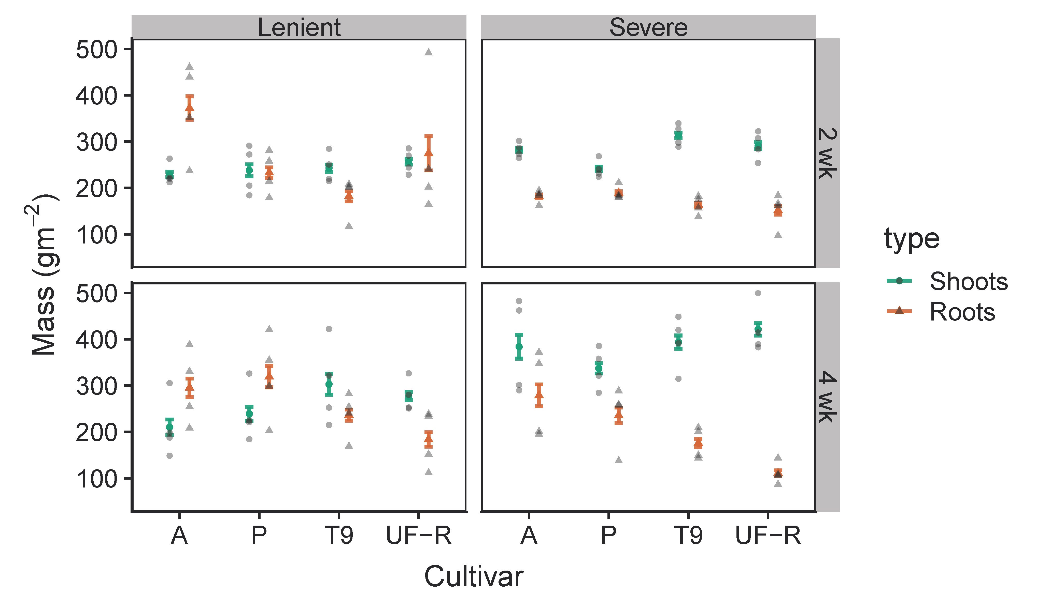

**Figure 1.** Raw data (g/m2) plotted as circles (shoots) and triangles (roots). Error bars show mean biomass (g/m2) ± 1 s.e. for shoots (purple error bars) and roots (brown error bars). The panels are faceted by treatment combinations: intensity of defoliation on top (lenient 15 cm or severe 5 cm on top), and frequency of defoliation labeled on the right hand side (2 wk or 4 wk). The x-axis groups responses by cultivar: A = Argentine, P = Pensacola, T9 = Tifton-9 and UF-R = UF-Riata. Change (gm-2) to (g/m2) on the Y axis in this Figure and also in Figure 5

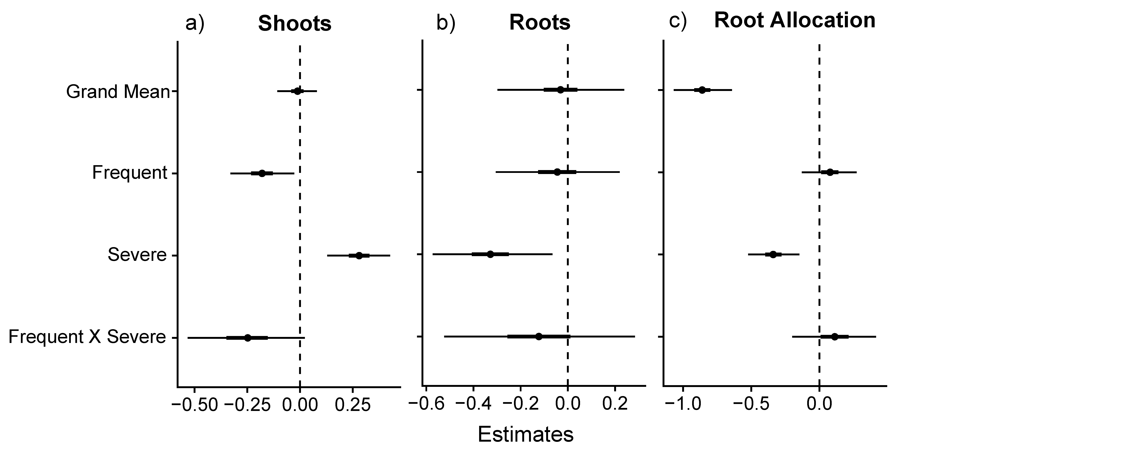

**Figure 2.** Fixed effects from varying-intercepts/varying-slopes Gamma regression model. Coefficients are plotted on the log-link scale and include a median (point), plus 50% (thick line) and 95% (thin line) credible intervals for: a) shoot production; b) root production; and c) root allocation. Where the entire 95% credible interval falls above or below zero, we can interpret that as a 97.5+% Bayesian probability of that coefficient having a positive or negative effect on the response, respectively.

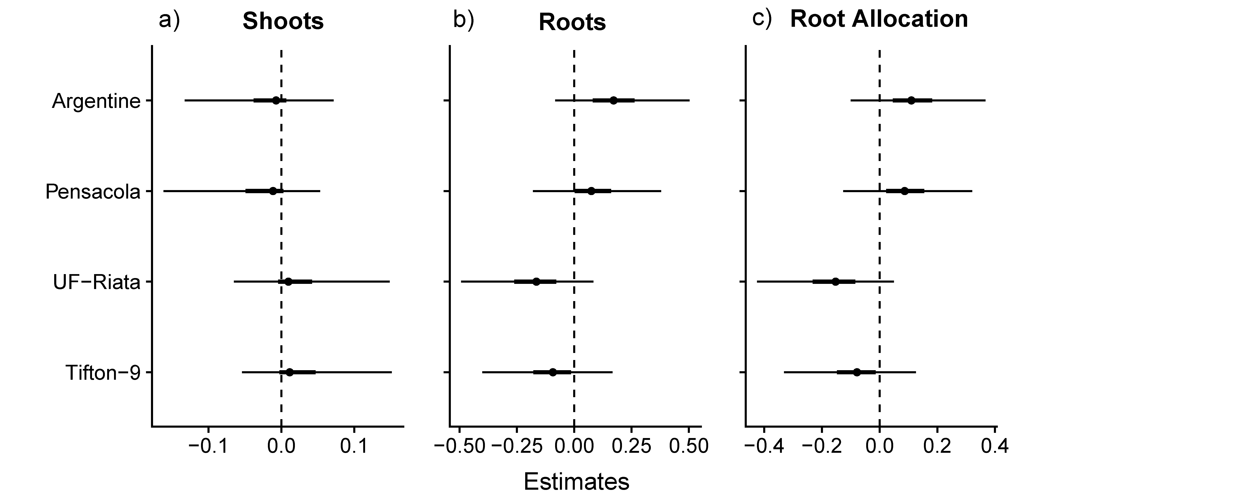

**Figure 3.** Varying-intercepts from the Gamma regression model for root production. Coefficients represent deviations of each cultivar (A = Argentine, P = Pensacola, T9 = Tifton-9 and UF-R = UF-Riata) from the overall mean (fixed effect coefficient), and are thus naturally centered at 0, where negative values represent lower than average performance and positive values higher than average performance. Plots include a median (point) plus 50% (thick line) and 95% (thin line) credible intervals. Where the entire 95% credible interval falls above or below zero, we can interpret that as a 97.5+% Bayesian probability of the cultivar having a higher or lower overall root production compared with the mean among all cultivars.

*Root production model*

We observed an average root production of 224 g/m2, where mild defoliation treatments were the highest with 262 g/m2 averaged across 2-wk and 4-wk defoliation frequencies, compared with severe defoliation with an average of 186 g/m2 (Figure 1). The fixed main effect estimate for severe defoliation was negative (-0.33 ± 0.12; Figure 2b), with >97.5% of posterior probability below 0, while the main effects of frequent defoliation and the interaction of frequent x severe defoliation were highly uncertain, with 95% credible intervals spanning a similar range above and below zero. Average root production across all treatment groups varied by cultivar more substantially than shoot production (Figure 3b), with the prostrate cultivars Argentine and Pensacola having greater root production than the upright cultivars UF-Riata and Tifton-9 (Figure 3b; Figure 4). The greatest contrast was between Argentine and UF-Riata, which had a median posterior difference of -0.36 on the log-link scale (Figure 4), which represents a 30% lower root production.

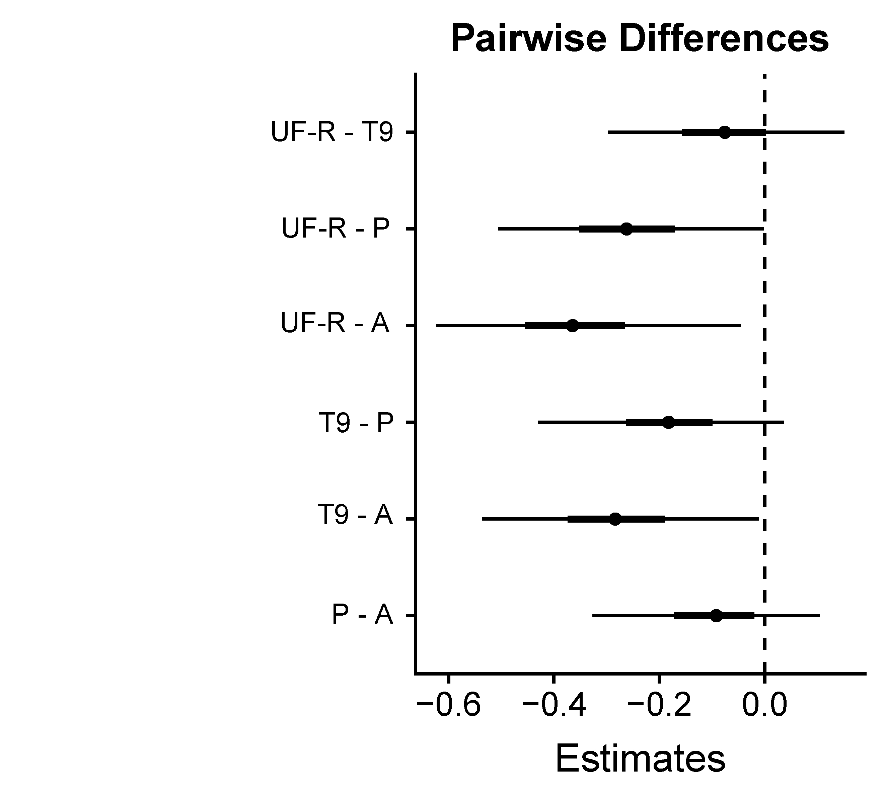

**Figure 4.** Pairwise contrasts among cultivars for the varying intercepts of the root allocation model. Key: A = Argentine, P = Pensacola, T9 = Tifton-9 and UF-R = UF-Riata. Plots include a median (point) plus 50% (thick line) and 95% (thin line) credible intervals. Where the entire 95% credible interval falls above or below zero, we can interpret that as a 97.5+% Bayesian probability of the first cultivar having a higher or lower root allocation, respectively, than the second cultivar.

*Root allocation*

The fixed main effect estimate for severe defoliation on root biomass allocation proportion was -0.34 ± 0.09 (Figure 2c), a very similar median estimate to that for root production, although with a smaller uncertainty (s.e. = 0.09 vs. 0.12). This result represents a median estimate of 29% reduced allocation proportion to roots overall among cultivars and across both frequencies of defoliation with severe defoliation. Variation among cultivars was similar to that observed for root production (Figure 3c vs. Figure 3b), so we did not repeat the pairwise analysis since it would convey redundant information.

*Root production predictions*

The univariate regression between shoot and root production revealed a very weak (R2 = 0.09) relationship (Figure 5a). The full model that included treatment indicators and cultivar identity (as in the analyses above) yielded a median R2 of 0.45 (Figure 5b). After removing the varying intercepts/slopes by cultivar, this R2 value declined to 0.21 (see supplement), indicating that accounting for cultivar identity doubles model fit. Close examination of Figure 5b reveals that the full model accounted for observed variations in root production quite well in the range of 100−300 g/m2 but severely underpredicted root production when >300 g/m2.

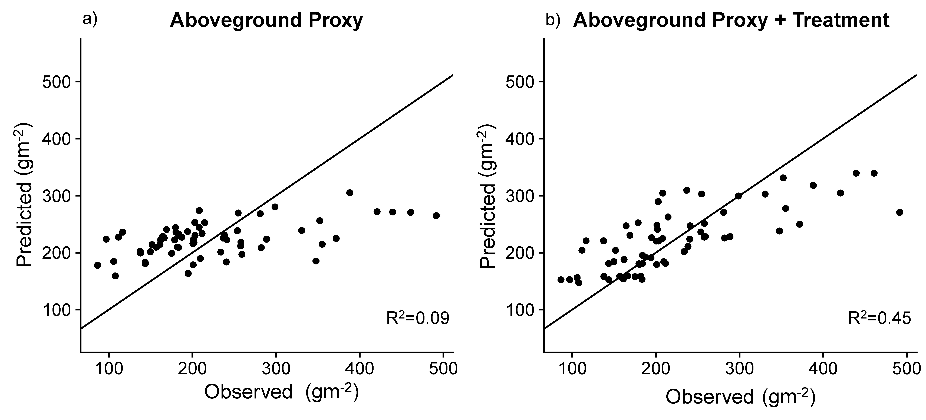

**Figure 5.** Shoot production does not predict root production. a) Predicted vs. observed scatterplot for root production as predicted by shoot production as an above-ground proxy; and b) Predicted vs. observed scatterplot for root production as predicted by defoliation treatment, cultivar identity and shoot production. For reference, the 1:1 line of “perfect fit” is plotted along with an in-sample median Bayesian R2 for both predictive models.

**Discussion**

Severe defoliation resulted in substantially greater shoot production when applied infrequently, but reduced root production among the bahiagrass cultivars. Averaged across all defoliation treatments, root production was also more strongly variable among cultivars than was shoot production. Thus, our results suggest that severe defoliation can trigger a tradeoff between above-ground and below-ground allocation of photosynthate in managed subtropical pastures, and that the extent of this tradeoff depends in part on cultivar identity. Contrary to Georgiadis et al. (1989) and Briske and Richards (1995), who suggested that over-compensation was likely to occur only under water-limitation, or given concomitant fertilization, we found significantly greater shoot production in response to severe defoliation under limited fertility and abundant soil water. Compared with mild defoliation, all cultivars exhibited this compensatory above-ground growth response following severe defoliation, but only when defoliation was applied infrequently (similar to Gates et al. 1999). However, the severe but infrequent defoliation treatment that led to above-ground compensatory growth also suppressed root production. Thus, under low-input conditions, manipulating defoliation severity and frequency to enhance forage production could evoke a tradeoff between shoot and root production. Given the substantial literature demonstrating the importance of root carbon for maintenance of soil carbon pools (Rasse et al. 2005; Wilson et al. 2018; Sokol et al. 2019), these altered patterns of allocation of photosynthate may have significant consequences for carbon cycling, and hence soil carbon sequestration services, in managed subtropical pastures. Moreover, use of simple above-ground proxies, such as leaf area/biomass, is unlikely to yield accurate predictions of root production over large spatial scales.

Impacts of severe defoliation on shoot and root responses (hypotheses 1 and 2)

In terms of our hypothesis 1, we found support for the existence of a compensatory growth response mechanism in Bahiagrass, but rather than an indifferent effect on root productivity, we observed a somewhat reduced production (~28% reduction on average). Our results differ from the short-term responses measured by Ziter and Macdougall (2012) and Hamilton et al. (2008), where a single defoliation event stimulated root production and root exudation, respectively. Moreover, the results reported here appear to conflict with measurements of standing root biomass, root exudation rates and their connections to microbial biomass and soil carbon, across a system of long-term grazing exclosures on a similar pasture site, as reported in Wilson et al. (2018). These discrepancies suggest that root responses to short-term grazing/defoliation events can differ strongly from season-long responses to grazing regimens, where both severity and frequency of defoliation are expected to mediate plant regrowth strategies (Briske and Richards 1995). Moreover, longer term impacts of grazing exclusion (over many years) in bahiagrass-dominated subtropical pasture appear to involve pronounced phenotypic shifts in root:shoot ratios, whereby absence of grazing favors lower root:shoot ratios, even when holding species composition constant (Wilson et al. 2018). On the other hand, Thornton and Millard (1996) found that greater severity of defoliation resulted in lower root mass (but greater N uptake per unit of root mass), which is consistent with our findings.

Dawson et al. (2000) reported that weekly defoliation over a growing season reduced root biomass compared with no defoliation, but infrequent defoliation (every 8 weeks) had no effect. Our ambivalent findings on the role of frequency of defoliation were thus somewhat surprising. Although we observed marked suppression of variability of production under our severe + frequent treatment (see e.g. Figure 1), root production was not markedly lower than in our severe + infrequent treatment. However, our second hypothesis was upheld, in that the decrease in root production we observed was less variable across cultivars under severe + frequent defoliation. Despite this, it appears that in our system, severity, not frequency, of grazing is the more important determinant of root production of grass.

Cultivar variability in response to defoliation treatment (hypothesis 3)

We observed substantial overall variability in root production among the grass cultivars. However, it does not appear possible to predict cultivar-level below-ground responses to specific grazing regimens based on observations of above-ground compensatory growth responses. As we hypothesized (hypothesis 3), the cultivars selected for enhanced upright growth habit (Tifton 9, UF-Riata; Interrante et al. 2009), especially Tifton-9, exhibited less overall root production than the widely-naturalized prostrate types (Argentine, Pensacola), especially Argentine. On the other hand, all cultivars responded negatively to severe defoliation per se, and we observed similar total root production among all cultivars in the severe + frequent defoliation treatment, a scenario reasonably representative of overstocked pastures. These results contradict the hypothesis that more grazing-tolerant genotypes, in our case Argentine and Pensacola, will have lower root production as a consequence of greater post-grazing allocation of resources to shoot regrowth (Briske and Richards 1995; Dawson et al. 2000). Instead, it appears that cultivars simply vary in root growth potential, but that severe defoliation, especially when applied frequently, overwhelms this variability.

Spatial correlation of shoot and root production (hypothesis 4)

Contrary to our hypothesis 4, our study revealed that shoot and root production are decoupled at fine spatial scales, at least in our experimental plots, with shoot production explaining only 8% of the in-sample variation in root production. By contrast, defoliation treatment and especially cultivar identity appeared to be very important for predicting root production in this system, together accounting for roughly half the observed variance in root production. Gill et al. (2002) reported some success in predicting below-ground NPP using an algorithm based only on above-ground biomass and climate, but their model consistently under-predicted root production in more productive sites. Interestingly, we observed a similar severe under-prediction of root production in our more productive plots. Thus, we caution against using above-ground proxies to predict below-ground production, even within uniform and homogeneous ecosystems, such as the planted pasture system where we worked. Our results suggest that knowledge of grazing management and cultivar identity, in addition to species-level variations in composition (Steinbeiss et al. 2008; Tilman et al. 2012), are critical for generating accurate predictions of BNPP. Moreover, half of the variance in below-ground production was unexplained, even in our best model, suggesting significant spatial heterogeneity in root system productivity that should be investigated further. Given recent calls highlighting the importance of plant roots and their production in achieving future progress in biogeochemical modeling and the quest to find reliable, scalable above-ground proxies to infer root processes indirectly (Iversen et al. 2017; Malhotra et al. 2018), our results are a sobering reminder of the challenges inherent to linking above- and below-ground production. Accordingly, we suggest that a high priority for future research is to study below-ground root-rhizosphere processes using spatially-explicit sampling protocols designed to maximize insight into heterogeneity at various spatial and temporal scales.

On a large scale, McNaughton et al. (1998) found that grazing intensity was uncorrelated with standing root biomass or productivity in the Serengeti. However, in speciose natural grasslands plant diversity may confer a stabilizing influence on root production (Fornara et al. 2009; Tilman et al. 2012). By contrast, monoculture pasture systems may respond more like mesocosm systems, where high defoliation intensity is associated with reduced root biomass (Bardgett et al. 1998). Moreover, since a large proportion of planted pastures (particularly in the subtropics) are dominated by single species, variation in root production among cultivars may represent an especially important component of diversity. Grazing management may need to be matched to cultivar-level characteristics to optimize both forage and root production, and establishment of planted pastures with multiple cultivars or genotypes may be a viable, yet under-appreciated, strategy for enhancing functional diversity. For instance, combining upright and prostrate cultivars may introduce beneficial genotypic diversity that could maximize utilization of both above- and below-ground resources via niche complementarity (Avolio et al. 2011; Chang and Smith 2014). Additionally, cultivar-level variability suggests the potential for ecologists, agronomists and physiologists to collaborate with plant breeders to improve the sustainability of grassland agroecosystems by development of improved forage cultivars selected for superior below-ground traits.

Overall, our results suggest that intermittent severe defoliation can elicit much greater shoot growth, but have neutral or negative effects on root production. It is possible that a more moderate defoliation intensity than we tested would have led to similar stimulation of above-ground compensation without the negative consequences for root production, a possibility our study was not designed to test. Neither did our study consider impacts of defoliation on rhizome biomass, but we stress that our intent was to focus on root production, since it appears to be of greater relevance for soil carbon sequestration than other compartments of plant biomass (Rasse et al. 2005). Likewise, it is also possible that the low levels of fine root production we measured may have been compensated for by greater rhizodeposition/root exudation. However, this possibility seems unlikely given that rates of root exudation generally correlate closely with fine root surface area (Jones et al. 2009; Wilson et al. 2018).

The main limitation of our work is that realistic animal grazing management can differ from experimentally imposed defoliation in 2 major ways: 1) grazing impacts will fall along a spectrum of timing and intensity with more intermediate values than can be tested in a randomized factorial experiment; and 2) grazers will return a certain fraction of consumed carbon and nutrients in the form of manure and urine, creating heterogeneous patches of varying nutrient availability. Moreover, we also caution that year-to-year variability in growing conditions can induce variability in experimental effects. Ideally, we recommend that medium-term (3+ years) field studies of controlled grazing (or defoliation) be conducted to properly estimate the random effects of such year-to-year environmental fluctuations. In addition to recommending greater future consideration of intraspecific variations in below-ground responses to grazing, our work supports the need to perform season-long measures of below-ground productivity to obtain reliable estimates of below-ground production that can be used to parameterize soil carbon models.

**Conclusions**

Across our four tested cultivars, we found that severe defoliation, regardless of frequency, suppressed root production, while infrequently applied severe defoliation increased shoot production. Thus, it appears that manipulating timing and intensity of grazing to optimize forage production might evoke a negative tradeoff with root production. Unfortunately, our data suggest that reliance on above-ground proxies to predict belowground processes is not justified, at least for subtropical pastures.

We suggest that longer-term field manipulations are necessary to evaluate a suite of grazing management scenarios across plant composition treatments to improve our ability to design management strategies for grassland agroecosystems to meet both above-ground (forage) production goals and optimize below-ground production so as to improve soil carbon sequestration, nutrient retention and water cycling.

**Acknowledgments**

For significant assistance with field work and data collection we thank Carly Althoff, Jessica Wilson, Trevor Caughlin, Anand Roopsind, James Estrada and Bryan Tarbox.

**References**

Augustine DJ; Dijkstra FA; Iii EWH; Morgan JA. 2011. Rhizosphere interactions, carbon allocation, and nitrogen acquisition of two perennial North American grasses in response to defoliation and elevated atmospheric CO2. Oecologia 165:755–770.

Avolio ML; Chang CC; Smith MD. 2011. Assessing fine-scale genotypic structure of a dominant species in native grasslands. The American Midland Naturalist 165:211–224.

Balogianni VG; Wilson SD; Vaness BM; MacDougall AS; Pinno BD. 2014. Different root and shoot responses to mowing and fertility in native and invaded grassland. Rangeland Ecology & Management 67:39–45.

Bardgett RD; Wardle DA; Yeates GW. 1998. Linking above-ground and below-ground interactions: how plant responses to foliar herbivory influence soil organisms. Soil Biology and Biochemistry 30:1867–1878.

Beaty ER; Stanley RL; Powell J. 1968. Effect of height of cut on yield of Pensacola bahiagrass. Agronomy Journal 60:356–358.

Briske D; Richards J. 1995. Plant responses to defoliation: a physiological, morphological and demographic evaluation. In: Wildland plants: physiological ecology and developmental morphology, Bedunah DJ and Sosebee RE eds. p. 635–710. Society for Range Management (Littleton, CO).

Cahill KN; Kucharik CJ; Foley JA. 2009. Prairie restoration and carbon sequestration: difficulties quantifying C sources and sinks using a biometric approach. Ecological Applications 19:2185–2201.

Carman JG. 1985. Morphological characterization and defoliation responses of selected *Schizachyrium scoparium* genotypes. The American Midland Naturalist 114:37–43.

Carpenter B; Gelman A; Hoffman MD; Lee D; Goodrich B; Betancourt M; Brubaker M; Guo J; Li P; Riddell A. 2017. Stan: A probabilistic programming language. *Journal of statistical software*, *76*(1).

Chang CC; Smith MD. 2014. Resource availability modulates above- and below-ground competitive interactions between genotypes of a dominant C4 grass. Functional Ecology 28:1041–1051.

Chen W; Zhang Q; Cihlar J; Bauhus J; Price DT. 2004. Estimating fine-root biomass and production of boreal and cool temperate forests using aboveground measurements: A new approach. Plant Soil 265:31–46.

Cooley KD; Sollenberger LE; Blount AR; da Silva LS; Kohmann MM; Aryal P; Dubeux JCB; Silveira ML. 2019. A modified ingrowth core to measure root-rhizome accumulation of perennial forage species. Agronomy Journal 111:3393–3397.

Dawson LA; Grayston SJ; Paterson E. 2000. Effects of grazing on the roots and rhizosphere of grasses. In: Lemaire G; Hodgson J; de Moraes A; Nabinger C; Carvalho PC de F, eds. Grassland ecophysiology and grazing ecology.CABI, Wallingford. p. 61–84.

Doss BD; Ashley DA; Bennett OL. 1960. Effect of soil moisture regime on root distribution of warm season forage species. Agronomy Journal 52:569–572.

Fornara DA; Tilman D; Hobbie SE. 2009. Linkages between plant functional composition, fine root processes and potential soil N mineralization rates. Journal of Ecology 97:48–56.

Fuhlendorf SD; Engle DM. 2001. Restoring heterogeneity on rangelands: ecosystem management based on evolutionary grazing patterns. BioScience 51:625–632.

Gates RN; Hill GM; Burton GW. 1999. Response of selected and unselected bahiagrass populations to defoliation. Agronomy Journal 91:787–795.

Gelman A; Hill J. 2007. Data analysis using regression and multilevel/hierarchical models. Cambridge University Press, Cambridge, England.

Gelman A; Hill J; Yajima M. 2012. Why we (usually) don’t have to worry about multiple comparisons. Journal of Research on Educational Effectiveness 5:189–211.

Gelman, A., Carlin, J. B., Stern, H. S., Dunson, D. B., Vehtari, A., & Rubin, D. B. (2013). Bayesian data analysis. CRC press (Boca Raton, FL).

Gelman A; Goodrich B; Gabry J; Vehtari A. 2018. R-squared for Bayesian regression models. The American Statistician 73:307–309.

Georgiadis NJ; Ruess RW; McNaughton SJ; Western D. 1989. Ecological conditions that determine when grazing stimulates grass production. Oecologia 81:316–322.

Gill RA; Kelly RH; Parton WJ; Day KA; Jackson RB; Morgan JA; Scurlock JMO; Tieszen LL; Castle JV; Ojima DS; Zhang XS. 2002. Using simple environmental variables to estimate below-ground productivity in grasslands. Global Ecology and Biogeography 11:79–86.

Gilmanov TG; Soussana JF; Aires L; Allard V; Ammann C; Balzarolo M; Barcza Z; Bernhofer C; Campbell CL; Cernusca A; Cescatti A; Clifton-Brown J; Dirks BOM; Dore S; Eugster W; Fuhrer J; Gimeno C; Gruenwald W; Haszpra L; Hensen A; Ibrom A; Jacobs AFG; Jones MB; Lanigan G; Laurila T; Lohila A; Manca G; Marcolla B; Nagy Z; Pilegaard K; Pinter K; Pio C; Raschi A; Rogiers N; Sanz MJ; Stefani P; Sutton M; Tuba Z; Valentini R; Williams ML; Wohlfahrt G. 2007. Partitioning European grassland net ecosystem CO2 exchange into gross primary productivity and ecosystem respiration using light response function analysis. Agriculture, Ecosystems & Environment 121:93–120.

Gu Y; Wylie BK; Bliss NB. 2013. Mapping grassland productivity with 250-m eMODIS NDVI and SSURGO database over the Greater Platte River Basin, USA. Ecological Indicators 24:31–36.

Hafner S; Unteregelsbacher S; Seeber E; Lena B; Xu X; Li X; Guggenberger G; Miehe G; Kuzyakov Y. 2012. Effect of grazing on carbon stocks and assimilate partitioning in a Tibetan montane pasture revealed by 13 CO2 pulse labeling. Global Change Biology 18:528–538.

Hamilton EW; Frank DA. 2001. Can plants stimulate soil microbes and their own nutrient supply? Evidence from a grazing tolerant grass. Ecology 82:2397–2402.

Hamilton III EW; Frank DA; Hinchey PM; Murray TR. 2008. Defoliation induces root exudation and triggers positive rhizospheric feedbacks in a temperate grassland. Soil Biology and Biochemistry 40:2865–2873.

Houborg RM; Soegaard H. 2004. Regional simulation of ecosystem CO2 and water vapor exchange for agricultural land using NOAA AVHRR and Terra MODIS satellite data. Application to Zealand, Denmark. Remote Sensing of Environment 93:150–167.

Hui D; Jackson RB. 2006. Geographical and interannual variability in biomass partitioning in grassland ecosystems: a synthesis of field data. New Phytologist 169:85–93.

Interrante SM; Sollenberger LE; Blount AR; Coleman SW; White UR; Liu K. 2009. Defoliation management of bahiagrass germplasm affects cover and persistence-related responses. Agronomy Journal 101:1381–1387.

Iversen CM; McCormack ML; Powell AS; Blackwood CB; Freschet GT; Kattge J; Roumet C; Stover DB; Soudzilovskaia NA; Valverde‐Barrantes OJ; van Bedegom PM; Violle C. 2017. A global fine-root ecology database to address below-ground challenges in plant ecology. New Phytologist 215:15–26.

Johnson LC; Matchett JR. 2001. Fire and grazing regulate belowground processes in tallgrass prairie. Ecology 82:3377–3389.

Jones DL; Nguyen C; Finlay RD. 2009. Carbon flow in the rhizosphere: carbon trading at the soil–root interface. Plant Soil 321:5–33.

Klumpp K; Fontaine S; Attard E; Le Roux X; Gleixner G; Soussana J-F. 2009. Grazing triggers soil carbon loss by altering plant roots and their control on soil microbial community. Journal of Ecology 97:876–885.

Knapp AK; Blair JM; Briggs JM; Collins SL; Hartnett DC; Johnson LC; Towne EG. 1999. The keystone role of bison in north american tallgrass prairie. BioScience 49:39–50.

Lal R. 2010. Managing soils and ecosystems for mitigating anthropogenic carbon emissions and advancing global food security. BioScience 60:708–721.

Li S; Potter C; Hiatt C. 2012. Monitoring of net primary production in California rangelands using Landsat and MODIS satellite remote sensing. Natural Resources 3:56–65.

Madritch MD; Hunter MD. 2002. Phenotypic diversity influences ecosystem functioning in an Oak sandhills community. Ecology 83:2084–2090.

Makkonen K; Helmisaari H-S. 1999. Assessing fine-root biomass and production in a Scots pine stand – comparison of soil core and root ingrowth core methods. Plant and Soil 210:43–50.

Malhotra A; Sihi D; Iversen C. 2018. The fate of root carbon in soil: data and model gaps. Eos. Accessed (22 January 2020) https://eos.org/meeting-reports/the-fate-of-root-carbon-in-soil-data-and-model-gaps.

McNaughton SJ. 1983. Compensatory plant growth as a response to herbivory. Oikos 40:329–336.

McNaughton SJ. 1985. Ecology of a grazing ecosystem: the Serengeti. Ecological Monographs 55:259–294.

McNaughton SJ; Banyikwa FF; McNaughton MM. 1998. Root biomass and productivity in a grazing ecosystem: the Serengeti. Ecology 79:587–592.

McSherry ME; Ritchie ME. 2013. Effects of grazing on grassland soil carbon: a global review. Global Change Biology 19:1347–1357.

Milchunas DG; Lauenroth WK. 1993. Quantitative effects of grazing on vegetation and soils over a global range of environments. Ecological Monographs 63:327–366.

Poirier V; Roumet C; Munson AD. 2018. The root of the matter: Linking root traits and soil organic matter stabilization processes. Soil Biology and Biochemistry 120:246–259.

Rasse DP; Rumpel C; Dignac M-F. 2005. Is soil carbon mostly root carbon? Mechanisms for a specific stabilisation. Plant Soil 269:341–356.

Schabenberger O; Jr TGGJPW; Kong F. 2000. Collections of simple effects and their relationship to main effects and interactions in factorials. The American Statistician 54:210–214.

Scurlock JMO; Hall DO. 1998. The global carbon sink: a grassland perspective. Global Change Biology 4:229–233.

Silveira ML; Obour AK; Arthington J; Sollenberger LE. 2011. The cow-calf industry and water quality in South Florida, USA: a review. Nutrient Cycling in Agroecosystems 89:439–452.

Sokol NW; Kuebbing SE; Karlsen-Ayala E; Bradford MA. 2019. Evidence for the primacy of living root inputs, not root or shoot litter, in forming soil organic carbon. New Phytologist 221:233–246.

Stanley RL; Beaty ER; Powell JD. 1977. Forage yield and percent cell wall constituents of Pensacola bahiagrass as related to N fertilization and clipping height. Agronomy Journal 69:501–504.

Steinbeiss S; Beßler H; Engels C; Temperton VM; Buchmann N; Roscher C; Kreutziger Y; Baade J; Habekost M; Gleixner G. 2008. Plant diversity positively affects short-term soil carbon storage in experimental grasslands. Global Change Biology 14:2937–2949.

Thornton B; Millard P. 1996. Effects of severity of defoliation on root functioning in grasses. Journal of Range Management 49:443–447.

Tilman D; Reich PB; Isbell F. 2012. Biodiversity impacts ecosystem productivity as much as resources, disturbance, or herbivory. PNAS 109:10394–10397.

Vendramini JMB; Sollenberger LE; Blount AR; Aguiar AD; Galzerano L; Valente ALS; Alves E; Custodio L. 2013. Bahiagrass cultivar response to grazing frequency with limited nitrogen fertilization. Agronomy Journal 105:938–944.

Whitham TG; Bailey JK; Schweitzer JA; Shuster SM; Bangert RK; LeRoy CJ; Lonsdorf EV; Allan GJ; DiFazio SP; Potts BM; Fischer DG; Gehring CA; Lindroth RL; Marks JC; Hart SC; Wimp GM; Wooley SC. 2006. A framework for community and ecosystem genetics: from genes to ecosystems. Nature Reviews Genetics 7:510–523.

Wilson CH; Strickland MS; Hutchings JA; Bianchi TS; Flory SL. 2018. Grazing enhances belowground carbon allocation, microbial biomass, and soil carbon in a subtropical grassland. Global Change Biology 24:2997–3009.

Zhao W; Chen S-P; Lin G-H. 2008. Compensatory growth responses to clipping defoliation in *Leymus chinensis* (Poaceae) under nutrient addition and water deficiency conditions. Plant Ecology 196:85–99.

Ziter C; MacDougall AS. 2012. Nutrients and defoliation increase soil carbon inputs in grassland. Ecology 94:106–116.